Maths in Griffin scripts

Daniele Ferraretto

Thursday, January 25, 2016

This documents follows the first version, giving an example of how the calculations on TF, SF and RF data are applied in R to the raw data. I will skip the descriptive part of the database focusing straight to the output values. The attached *Griffin_20140424.xls* file contains the fieldwork data I will use as example for the calculations.  
The main outcome from this work has been finding out a bug in the script that reads the .xls files (all the samples starting from November 2013) and affected the output Nx values. Even if the script converted correctly them from the Nx concentration to N-Nx, subtracting the blanks and making 0 any negative values, it ultimately saved the raw untouched lab data in the database, ignoring the transformations. This problem has been fixed and the new results are available at the end of this document, together with some extra information for each relevant transformation contained in the scripts.

# Part 1. From paper to database: Griffin.SQLite

The scripts converting the raw field and lab data into values have been written by Mike Spencer. I will show which information is contained in the SQLite db *Griffin.SQlite* and briefly describe the calculations made to obtain the data written into the **fielddata** and **labdata** tables.

*NOTE: There is an error in labelling the site for pecipitation and for streamflow. As at the moment it doesn't affect the calculations (site is a reduntant information) I will try to correct it after completing this document*

## Example sampling date: 24th April 2014.

In order to make the data more readable, only the Control plot and precipitation data have been extracted from the field data. Similarly, only NO3.N and NH4.N data from lab data are displayed (ignoring pH, litter mass and POC concentration), to reduce the number of lines of the printout. These values are generated from the calculations as displayed in the *Maths in Griffin scripts* file, in particular:

dbGetQuery(db, "SELECT date, sample, variable, vals FROM fielddata WHERE (variable IS 'through vol' OR variable IS 'through depth' OR variable IS 'stem vol' OR variable IS 'precip depth') AND (date = '2014-04-24') AND (site IS 'Control' OR site IS 'Both') ORDER BY variable DESC")

## date sample variable vals  
## 1 2014-04-24 C10T1 through vol 28.899235  
## 2 2014-04-24 C10T2 through vol 26.987189  
## 3 2014-04-24 C10T3 through vol 24.101517  
## 4 2014-04-24 C11T1 through vol 16.516182  
## 5 2014-04-24 C11T2 through vol 26.629962  
## 6 2014-04-24 C11T3 through vol 27.894185  
## 7 2014-04-24 C12T1 through vol 36.547419  
## 8 2014-04-24 C12T2 through vol 17.426960  
## 9 2014-04-24 C12T3 through vol 36.547419  
## 10 2014-04-24 C10T1 through depth 15.369609  
## 11 2014-04-24 C10T2 through depth 14.616927  
## 12 2014-04-24 C10T3 through depth 12.769751  
## 13 2014-04-24 C11T1 through depth 8.858722  
## 14 2014-04-24 C11T2 through depth 14.220704  
## 15 2014-04-24 C11T3 through depth 14.895813  
## 16 2014-04-24 C12T1 through depth 19.602801  
## 17 2014-04-24 C12T2 through depth 9.438871  
## 18 2014-04-24 C12T3 through depth 19.695500  
## 19 2014-04-24 C10S1 stem vol 19.339006  
## 20 2014-04-24 C10S2 stem vol 3.192934  
## 21 2014-04-24 C10S3 stem vol NA  
## 22 2014-04-24 C11S1 stem vol 4.646845  
## 23 2014-04-24 C11S2 stem vol 0.285112  
## 24 2014-04-24 C11S3 stem vol 9.008578  
## 25 2014-04-24 C11S4 stem vol 3.192934  
## 26 2014-04-24 C11S5 stem vol 4.646845  
## 27 2014-04-24 C11S6 stem vol 13.602868  
## 28 2014-04-24 C11S7 stem vol 4.042639  
## 29 2014-04-24 C12S1 stem vol 17.426960  
## 30 2014-04-24 C12S2 stem vol 11.690822  
## 31 2014-04-24 C12S3 stem vol 15.514914  
## 32 2014-04-24 C30D1 precip depth 2.107019  
## 33 2014-04-24 C30D2 precip depth 3.750458  
## 34 2014-04-24 C31D1 precip depth 1.588548

dbGetQuery(db, "SELECT date, sample, variable, vals FROM labdata WHERE ( variable IS 'NO3.N' OR variable IS 'NH4.N') AND (date = '2014-04-24') AND (site IS 'Control' OR site IS 'Both') ORDER BY variable DESC")

## date sample variable vals  
## 1 2014-04-24 Blank 1 NO3.N 0.03793548  
## 2 2014-04-24 Blank 2 NO3.N 0.02416129  
## 3 2014-04-24 C10S1 NO3.N 0.25053226  
## 4 2014-04-24 C10S2 NO3.N 0.03646774  
## 5 2014-04-24 C10S3 NO3.N 0.07079032  
## 6 2014-04-24 C10T1 NO3.N 1.86595161  
## 7 2014-04-24 C10T2 NO3.N 1.99759677  
## 8 2014-04-24 C10T3 NO3.N 2.09356452  
## 9 2014-04-24 C11S1 NO3.N 0.02540323  
## 10 2014-04-24 C11S2 NO3.N 0.56530645  
## 11 2014-04-24 C11S3 NO3.N 0.45240323  
## 12 2014-04-24 C11S4 NO3.N 0.08546774  
## 13 2014-04-24 C11S5 NO3.N 0.54814516  
## 14 2014-04-24 C11S6 NO3.N 1.21811290  
## 15 2014-04-24 C11S7 NO3.N 0.14350000  
## 16 2014-04-24 C11T1 NO3.N 1.80317742  
## 17 2014-04-24 C11T2 NO3.N 1.77156452  
## 18 2014-04-24 C11T3 NO3.N 1.46808065  
## 19 2014-04-24 C12S1 NO3.N 1.77382258  
## 20 2014-04-24 C12S2 NO3.N 0.22998387  
## 21 2014-04-24 C12S3 NO3.N 1.55772581  
## 22 2014-04-24 C12T1 NO3.N 1.34862903  
## 23 2014-04-24 C12T2 NO3.N 2.07279032  
## 24 2014-04-24 C12T3 NO3.N 1.97659677  
## 25 2014-04-24 C20SW1 NO3.N 0.01975806  
## 26 2014-04-24 C21SW1 NO3.N 0.13469355  
## 27 2014-04-24 C30D1 NO3.N 1.35269355  
## 28 2014-04-24 C30D2 NO3.N 3.18985484  
## 29 2014-04-24 C31D1 NO3.N 1.54824194  
## 30 2014-04-24 Blank 1 NH4.N 0.02100000  
## 31 2014-04-24 Blank 2 NH4.N 0.02022222  
## 32 2014-04-24 C10S1 NH4.N 0.12405556  
## 33 2014-04-24 C10S2 NH4.N 0.64438889  
## 34 2014-04-24 C10S3 NH4.N 0.95783333  
## 35 2014-04-24 C10T1 NH4.N 1.20283333  
## 36 2014-04-24 C10T2 NH4.N 1.12272222  
## 37 2014-04-24 C10T3 NH4.N 1.25805556  
## 38 2014-04-24 C11S1 NH4.N 0.33483333  
## 39 2014-04-24 C11S2 NH4.N 1.42761111  
## 40 2014-04-24 C11S3 NH4.N 0.13416667  
## 41 2014-04-24 C11S4 NH4.N 0.33327778  
## 42 2014-04-24 C11S5 NH4.N 0.49038889  
## 43 2014-04-24 C11S6 NH4.N 0.22361111  
## 44 2014-04-24 C11S7 NH4.N 0.54405556  
## 45 2014-04-24 C11T1 NH4.N 1.01461111  
## 46 2014-04-24 C11T2 NH4.N 1.14527778  
## 47 2014-04-24 C11T3 NH4.N 0.84816667  
## 48 2014-04-24 C12S1 NH4.N 0.14505556  
## 49 2014-04-24 C12S2 NH4.N 0.09216667  
## 50 2014-04-24 C12S3 NH4.N 0.22438889  
## 51 2014-04-24 C12T1 NH4.N 0.77427778  
## 52 2014-04-24 C12T2 NH4.N 1.02472222  
## 53 2014-04-24 C12T3 NH4.N 0.97727778  
## 54 2014-04-24 C20SW1 NH4.N 0.00000000  
## 55 2014-04-24 C21SW1 NH4.N 0.01050000  
## 56 2014-04-24 C30D1 NH4.N 0.64672222  
## 57 2014-04-24 C30D2 NH4.N 1.75272222  
## 58 2014-04-24 C31D1 NH4.N 0.33172222

### Variables in fielddata: how they are calculated

For the raw data, see to the .xls file.

#### precip depth

$precipdepth=[(Bottle.full.g-Bottle.empty.g-H3PO4.g)/funnel/days]*10$,  
where $funnel=pi*7.5^{2}$ = area funnel, $days$ 
 = days passed since last sampling (27 days since 25 March 2014)

#### stem vol (l)

Samples are diveded into small/large, then volumes are calculated as: $$stemvol[large]=(stem.Depth.cm[large]-0.8857)/0.523 \\ stemvol[small]=(stem.Depth.cm[small]-0.6078)/1.3756$$

#### through vol (l)

Volumes are calculated according to the barrel shape, as $$throughvol[circle]=(through.Depth.cm[circle]-0.8857)/0.523 \\ throughvol[square]=(through.Depth.cm[square]-0.9357)/0.791$$

#### through depth

$throughdepth=(through.vol*{10}^{6})/(4.02*0.234*2*gutter+colander)/{10}^{6}$ where $gutter=cos(gut*pi/180),gut=angleofgutterwithsoil$ and $colander=pi*(12.25/100)^{2}$

### Variables in labdata: how they are calculated

#### Nitrate

$N-NO3.N=(NO3.concentration.mg.L*14/62)$; this is calculated for all samples including blanks. Then the mean blank N-NO3 value is calculated and subtracted from the N-NO3 values. Values lower than 0 are made 0

$N-NH4.N=NH4.concentration.mg.L*14/18$; this is calculated for all samples including blanks. Then the mean blank N-NH4 value is calculated and subtracted from the N-NH4 values. Values lower than 0 are made 0

# Part 2. From Griffin.SQLite to daily values: Daily_Griffin.SQLite

Here I extract an example of the daily values as they have been saved in the new Daily.Griffin.SQLite db. Now the data that have been split into daily data can be grouped into monthly data or into any other period of time. The db follows the rationale of "Griffin.SQLite": data are collected into 2 tables - fielddata and labdata. To make this readable I will extract a single day belonging to the previous sampling interval to show for comparison with the cumulated data previously shown

dbGetQuery(db, "SELECT date, sample, site, variable, vals FROM fielddata WHERE (variable IS 'through vol' OR variable IS 'through depth' OR variable IS 'stem vol' OR variable IS 'precip depth') AND (date = '2014-04-20') AND (site IS 'Control' OR site IS 'Both') ORDER BY variable DESC")

## date sample site variable vals  
## 1 2014-04-20 C10T1 Control through vol 1.03211600  
## 2 2014-04-20 C10T2 Control through vol 0.96382820  
## 3 2014-04-20 C10T3 Control through vol 0.86076850  
## 4 2014-04-20 C11T1 Control through vol 0.58986360  
## 5 2014-04-20 C11T2 Control through vol 0.95107010  
## 6 2014-04-20 C11T3 Control through vol 0.99622090  
## 7 2014-04-20 C12T1 Control through vol 1.30526500  
## 8 2014-04-20 C12T2 Control through vol 0.62239140  
## 9 2014-04-20 C12T3 Control through vol 1.30526500  
## 10 2014-04-20 C10T1 Control through depth 0.54891460  
## 11 2014-04-20 C10T2 Control through depth 0.52203310  
## 12 2014-04-20 C10T3 Control through depth 0.45606250  
## 13 2014-04-20 C11T1 Control through depth 0.31638290  
## 14 2014-04-20 C11T2 Control through depth 0.50788230  
## 15 2014-04-20 C11T3 Control through depth 0.53199330  
## 16 2014-04-20 C12T1 Control through depth 0.70010010  
## 17 2014-04-20 C12T2 Control through depth 0.33710250  
## 18 2014-04-20 C12T3 Control through depth 0.70341070  
## 19 2014-04-20 C10S1 Control stem vol 0.69067880  
## 20 2014-04-20 C10S2 Control stem vol 0.11403340  
## 21 2014-04-20 C10S3 Control stem vol NA  
## 22 2014-04-20 C11S1 Control stem vol 0.16595880  
## 23 2014-04-20 C11S2 Control stem vol 0.01018257  
## 24 2014-04-20 C11S3 Control stem vol 0.32173490  
## 25 2014-04-20 C11S4 Control stem vol 0.11403340  
## 26 2014-04-20 C11S5 Control stem vol 0.16595880  
## 27 2014-04-20 C11S6 Control stem vol 0.48581670  
## 28 2014-04-20 C11S7 Control stem vol 0.14438000  
## 29 2014-04-20 C12S1 Control stem vol 0.62239140  
## 30 2014-04-20 C12S2 Control stem vol 0.41752940  
## 31 2014-04-20 C12S3 Control stem vol 0.55410410  
## 32 2014-04-20 C30D1 Both precip depth 2.10701900  
## 33 2014-04-20 C30D2 Both precip depth 3.75045800  
## 34 2014-04-20 C31D1 Both precip depth 1.58854800

dbGetQuery(db, "SELECT date, site, sample, variable, vals FROM labdata WHERE ( variable IS 'NO3.N' OR variable IS 'NH4.N') AND (date = '2014-04-20') AND (site IS 'Control' OR site IS 'Both') ORDER BY variable DESC")

## date site sample variable vals  
## 1 2014-04-20 Both BLANK NO3.N 0.01332258  
## 2 2014-04-20 Both Blank 1 NO3.N 0.03793548  
## 3 2014-04-20 Both Blank 2 NO3.N 0.02416129  
## 4 2014-04-20 Control C10S1 NO3.N 0.25053230  
## 5 2014-04-20 Control C10S2 NO3.N 0.03646774  
## 6 2014-04-20 Control C10S3 NO3.N 0.07079032  
## 7 2014-04-20 Control C10T1 NO3.N 1.86595200  
## 8 2014-04-20 Control C10T2 NO3.N 1.99759700  
## 9 2014-04-20 Control C10T3 NO3.N 2.09356500  
## 10 2014-04-20 Control C11S1 NO3.N 0.02540323  
## 11 2014-04-20 Control C11S2 NO3.N 0.56530650  
## 12 2014-04-20 Control C11S3 NO3.N 0.45240320  
## 13 2014-04-20 Control C11S4 NO3.N 0.08546774  
## 14 2014-04-20 Control C11S5 NO3.N 0.54814520  
## 15 2014-04-20 Control C11S6 NO3.N 1.21811300  
## 16 2014-04-20 Control C11S7 NO3.N 0.14350000  
## 17 2014-04-20 Control C11T1 NO3.N 1.80317700  
## 18 2014-04-20 Control C11T2 NO3.N 1.77156500  
## 19 2014-04-20 Control C11T3 NO3.N 1.46808100  
## 20 2014-04-20 Control C12S1 NO3.N 1.77382300  
## 21 2014-04-20 Control C12S2 NO3.N 0.22998390  
## 22 2014-04-20 Control C12S3 NO3.N 1.55772600  
## 23 2014-04-20 Control C12T1 NO3.N 1.34862900  
## 24 2014-04-20 Control C12T2 NO3.N 2.07279000  
## 25 2014-04-20 Control C12T3 NO3.N 1.97659700  
## 26 2014-04-20 Control C20SW1 NO3.N 0.01975806  
## 27 2014-04-20 Control C21SW1 NO3.N 0.13469350  
## 28 2014-04-20 Control C30D1 NO3.N 1.35269400  
## 29 2014-04-20 Control C30D2 NO3.N 3.18985500  
## 30 2014-04-20 Control C30D3a NO3.N NA  
## 31 2014-04-20 Control C30D3b NO3.N 0.12600000  
## 32 2014-04-20 Control C31D1 NO3.N 1.54824200  
## 33 2014-04-20 Both BLANK NH4.N 0.02022222  
## 34 2014-04-20 Both Blank 1 NH4.N 0.02100000  
## 35 2014-04-20 Both Blank 2 NH4.N 0.02022222  
## 36 2014-04-20 Control C10S1 NH4.N 0.12405560  
## 37 2014-04-20 Control C10S2 NH4.N 0.64438890  
## 38 2014-04-20 Control C10S3 NH4.N 0.95783330  
## 39 2014-04-20 Control C10T1 NH4.N 1.20283300  
## 40 2014-04-20 Control C10T2 NH4.N 1.12272200  
## 41 2014-04-20 Control C10T3 NH4.N 1.25805600  
## 42 2014-04-20 Control C11S1 NH4.N 0.33483330  
## 43 2014-04-20 Control C11S2 NH4.N 1.42761100  
## 44 2014-04-20 Control C11S3 NH4.N 0.13416670  
## 45 2014-04-20 Control C11S4 NH4.N 0.33327780  
## 46 2014-04-20 Control C11S5 NH4.N 0.49038890  
## 47 2014-04-20 Control C11S6 NH4.N 0.22361110  
## 48 2014-04-20 Control C11S7 NH4.N 0.54405560  
## 49 2014-04-20 Control C11T1 NH4.N 1.01461100  
## 50 2014-04-20 Control C11T2 NH4.N 1.14527800  
## 51 2014-04-20 Control C11T3 NH4.N 0.84816670  
## 52 2014-04-20 Control C12S1 NH4.N 0.14505560  
## 53 2014-04-20 Control C12S2 NH4.N 0.09216667  
## 54 2014-04-20 Control C12S3 NH4.N 0.22438890  
## 55 2014-04-20 Control C12T1 NH4.N 0.77427780  
## 56 2014-04-20 Control C12T2 NH4.N 1.02472200  
## 57 2014-04-20 Control C12T3 NH4.N 0.97727780  
## 58 2014-04-20 Control C20SW1 NH4.N 0.00000000  
## 59 2014-04-20 Control C21SW1 NH4.N 0.01050000  
## 60 2014-04-20 Control C30D1 NH4.N 0.64672220  
## 61 2014-04-20 Control C30D2 NH4.N 1.75272200  
## 62 2014-04-20 Control C30D3a NH4.N NA  
## 63 2014-04-20 Control C30D3b NH4.N 0.10422220  
## 64 2014-04-20 Control C31D1 NH4.N 0.33172220

No special calculations have been done in the scripts, except dividing the cumulated values by number of days since last sampling. Most of the script is aimed to populate the daily database properly. NB: need to create a table

# Mean values per ha and aggregation by month

## Throughfall (TF)

This script merge the field data with N-NO3 and N-NH4 values. Before doing that a comparison between mean RF depths and mean TF depths are calculated to check for any incongruences in the field data. These values are shown in table @ at the end of this document

### N-Nx mass in TF

The script applies to both forms of Nx separately: N-NO3 and N-NH4. It is expressed in mg/m2/day and applies to each sample the following formula:

$$N-Nx=TF.daily.depth.mm*TF.Nx.daily.conc(mg/l)$$

**Example: C10T1**  
Throughfall volume and depth:

## date sample site variable vals  
## 1 2014-04-20 C10T1 Control through depth 0.5489146  
## 2 2014-04-20 C10T1 Control through vol 1.0321160

Throughfall N-NO3 and N-NH4 concentration:

## date sample site variable vals  
## 1 2014-04-20 C10T1 Control NH4.N 1.202833  
## 2 2014-04-20 C10T1 Control NO3.N 1.865952

The results of the script are 1.024mg/m2/d of N-NO3 and 0.660mg/m2/d of N-NH4.

The mean daily value among all available samples is then calculated, ignoring NA values. Results are 0.935 mg/m2/d of N-NO3 and 0.641mg/m2/d of N-NH4. These values are transformed into g/ha/day by multiplying each value per 10000/1000. Finally, the monthly mean TF value is calculated as the sum of the mean daily values per hectare. The values are shown in Table @. N-NO3 in April is 252.30 g/ha, which is consistent with the daily value, considering that the month is the sum of a daily value originated by the data collected on April the 24th and a daily value originated by the following collection in May (days 25th-30th April).

## Stemflow (SF)

### N-Nx mass in SF

Differently from TF the script calculates a mean by dbh class and date, followed by the mean (of means) among the dbh classes by date so that the resulting matrix (values per average tree) is multiplied by the average number of trees per ha. This number proceeds as a calculation from 2770trees/ha reduced by 5th row and 3rd tree removal during thinning) whereas 1421 trees/ha per C might be more appropriate, including a further reduction due to attrition. However at the moment such distinction has not be done. Similarly to TF, Na have been ignored when calculating the means (na.rm=TRUE)

*Number of trees per ha = 1865 trees/ha*  
This daily value is finally aggregated by month.

* STEP 1: calculate the mass of N-Nx per sample
* STEP 2: calculate the mean by dbh class and date
* STEP 3: calculate the mean by date (mean of means = the *average tree*)
* STEP 4: $N-Nx$ (g/ha/day) $=averagetree*1865/1000$
* STEP 5: aggregate the obtained daily value by month

To give an example of these steps I will extract the data from 20-04-2014. In order to reduce the number of lines I will only show N-NO3 values, omitting N-NH4.

## date sample site variable vals  
## 1 2014-04-20 C10S1 Control stem vol 0.69067880  
## 2 2014-04-20 C10S2 Control stem vol 0.11403340  
## 3 2014-04-20 C10S3 Control stem vol NA  
## 4 2014-04-20 C11S1 Control stem vol 0.16595880  
## 5 2014-04-20 C11S2 Control stem vol 0.01018257  
## 6 2014-04-20 C11S3 Control stem vol 0.32173490  
## 7 2014-04-20 C11S4 Control stem vol 0.11403340  
## 8 2014-04-20 C11S5 Control stem vol 0.16595880  
## 9 2014-04-20 C11S6 Control stem vol 0.48581670  
## 10 2014-04-20 C11S7 Control stem vol 0.14438000  
## 11 2014-04-20 C12S1 Control stem vol 0.62239140  
## 12 2014-04-20 C12S2 Control stem vol 0.41752940  
## 13 2014-04-20 C12S3 Control stem vol 0.55410410  
## 14 2014-04-20 T10S1 Treatment stem vol 0.01018257  
## 15 2014-04-20 T10S2 Treatment stem vol 0.16595880  
## 16 2014-04-20 T10S3 Treatment stem vol 0.26980950  
## 17 2014-04-20 T11S1 Treatment stem vol 0.97080240  
## 18 2014-04-20 T11S2 Treatment stem vol 0.42558570  
## 19 2014-04-20 T11S3 Treatment stem vol 0.34769760  
## 20 2014-04-20 T12S1 Treatment stem vol 0.78906350  
## 21 2014-04-20 T12S2 Treatment stem vol 0.03614527  
## 22 2014-04-20 T12S3 Treatment stem vol 0.06210796

## date sample site variable vals  
## 1 2014-04-20 C10S1 Control NO3.N 0.25053230  
## 2 2014-04-20 C10S2 Control NO3.N 0.03646774  
## 3 2014-04-20 C10S3 Control NO3.N 0.07079032  
## 4 2014-04-20 C10T1 Control NO3.N 1.86595200  
## 5 2014-04-20 C10T2 Control NO3.N 1.99759700  
## 6 2014-04-20 C10T3 Control NO3.N 2.09356500  
## 7 2014-04-20 C11S1 Control NO3.N 0.02540323  
## 8 2014-04-20 C11S2 Control NO3.N 0.56530650  
## 9 2014-04-20 C11S3 Control NO3.N 0.45240320  
## 10 2014-04-20 C11S4 Control NO3.N 0.08546774  
## 11 2014-04-20 C11S5 Control NO3.N 0.54814520  
## 12 2014-04-20 C11S6 Control NO3.N 1.21811300  
## 13 2014-04-20 C11S7 Control NO3.N 0.14350000  
## 14 2014-04-20 C11T1 Control NO3.N 1.80317700  
## 15 2014-04-20 C11T2 Control NO3.N 1.77156500  
## 16 2014-04-20 C11T3 Control NO3.N 1.46808100  
## 17 2014-04-20 C12S1 Control NO3.N 1.77382300  
## 18 2014-04-20 C12S2 Control NO3.N 0.22998390  
## 19 2014-04-20 C12S3 Control NO3.N 1.55772600  
## 20 2014-04-20 C12T1 Control NO3.N 1.34862900  
## 21 2014-04-20 C12T2 Control NO3.N 2.07279000  
## 22 2014-04-20 C12T3 Control NO3.N 1.97659700  
## 23 2014-04-20 T10S1 Treatment NO3.N 0.09269355  
## 24 2014-04-20 T10S2 Treatment NO3.N 0.24443550  
## 25 2014-04-20 T10S3 Treatment NO3.N 0.62627420  
## 26 2014-04-20 T10T1 Treatment NO3.N 1.62885500  
## 27 2014-04-20 T10T2 Treatment NO3.N 1.62275800  
## 28 2014-04-20 T10T3 Treatment NO3.N 1.75937100  
## 29 2014-04-20 T11S1 Treatment NO3.N 0.39956450  
## 30 2014-04-20 T11S2 Treatment NO3.N 0.69175810  
## 31 2014-04-20 T11S3 Treatment NO3.N 0.05385484  
## 32 2014-04-20 T11T1 Treatment NO3.N 1.75327400  
## 33 2014-04-20 T11T2 Treatment NO3.N 1.62095200  
## 34 2014-04-20 T11T3 Treatment NO3.N 1.62704800  
## 35 2014-04-20 T12S1 Treatment NO3.N 0.18527420  
## 36 2014-04-20 T12S2 Treatment NO3.N 0.04188710  
## 37 2014-04-20 T12S3 Treatment NO3.N 0.07575806  
## 38 2014-04-20 T12T1 Treatment NO3.N 2.04862900  
## 39 2014-04-20 T12T2 Treatment NO3.N 1.64488700  
## 40 2014-04-20 T12T3 Treatment NO3.N 1.98630600

**Example: Step 2 on 20-04-2014 N-NO3 SF data**

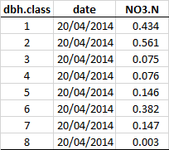  
*Table 1a: N-NO3 mass per dbh class, 24-04-2014*

  
*Table 2: N-NO3 mass per date ("average tree"), 24-04-2014*

## Rainfall (RF)

The script only considers the rainfall gauges and not the fog gauge. I will compare rain vs fog values and take a decision on how to consider the potentially extra N collected as fog (partly being dry dep?). The present assumption is, however, reductive in terms of N input and hence more cautious. Before proceeding with the below mentioned steps, the script calculates a mean RF depth (C30D1 and C31D1) to compare it with TF depth. Table @ is available at the end of this document

### N-Nx mass in RF

* STEP 1: calculate the daily mass of N-Nx per each RF sample (g/ha/day): $N-Nx=RF.daily.vol.mm*N-Nx.daily.conc*10000/1000$

**Example step1: 20-04-2014**

  
*Table 3: N-NO3 mass in RF on 24-04-2014*

* STEP 2: mean value by date
* STEP 3: aggregate by month  
  Being the last two steps straight forward, I will not add an example in this version of the document, but I can add a wider sample on request.

# N-NO3 and N-NH4 in RF, TF and SF.

All the following table are contained in the *RF_TF_SF_20160126.xls* file. This first table shows a comparison between RF and TF depths. The other 4 tables show Nx masses per month per flux (RF, TF, SF).

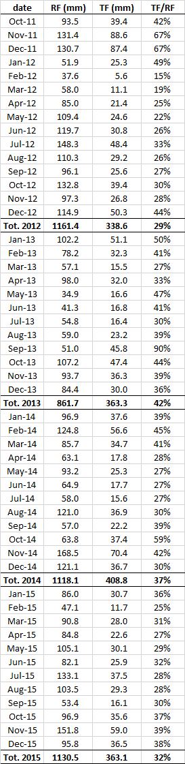  
*Table 4: RF and TF depth per month*

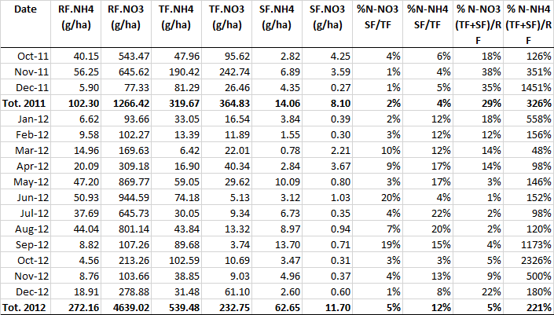  
*Table 5: N-Nx mass (g/ha), 2011/2012*

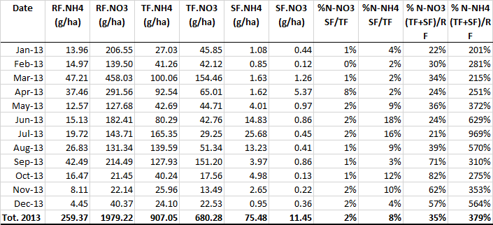  
*Table 6: N-Nx mass (g/ha), 2013*

  
*Table 7: N-Nx mass (g/ha), 2014*

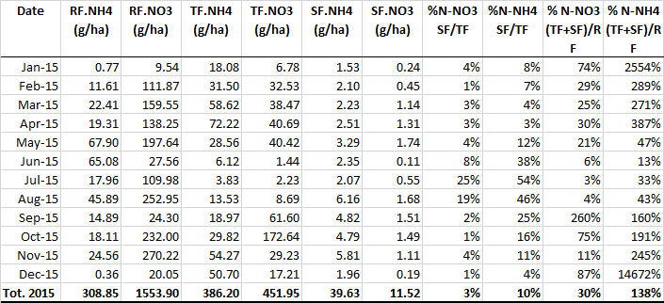  
*Table 8: N-Nx mass (g/ha), 2015*